Top 5 Fastest vs. Most Expensive Cars

This analysis compares the top 5 fastest accelerating sports cars (based on 0–60 MPH time) with the top 5 most expensive cars. It helps evaluate whether higher price directly correlates with superior acceleration performance.

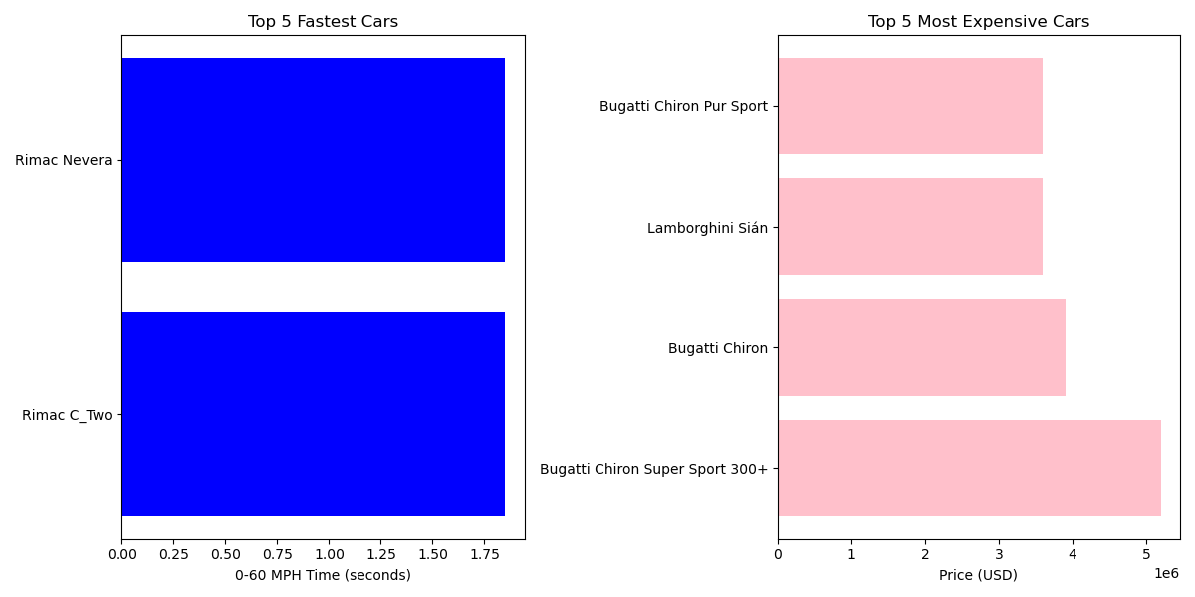

Findings:  
- The top 5 fastest cars are all Rimac models, showcasing elite electric acceleration.  
- The most expensive cars, dominated by Bugatti and Lamborghini, are fast but not the fastest.  
- Conclusion: A higher price does not always guarantee the best acceleration performance.